Requirements Document

**I.R.E.N.O Smart Assistant**

A Generative AI based smart assistant for electric utilities

Jul’25

Contents

1. Introduction 3

2. Objective 3

To build a natural language interface powered by Generative AI that enables users to: 3

3. Target Audience 3

4. Platform and Technology Stack 3

5. Requirements 4

5.1. User Requirements 4

5.2. User Requirements 4

5.3. User Requirements 4

6. Deliverables 4

7. Acceptance Criteria 4

8. Conclusion 5

9. Knowledge on Utility Assets 6

# 1. Introduction

This document outlines the scope for developing a Generative AI-based assistant solution to be integrated with the IRENO platform—Intuitive Response Enabled Network Operations.

IRENO is a unified platform that extracts actionable insights from electric utility IT-OT systems, offering a single pane of glass for network operators, field technicians, and leadership teams. It integrates IT-OT systems to deliver real-time insights, predictive analytics, and operational control. With GenAI infusion, IRENO will be able to consume information from smart meter operations, storm management, DER optimization, and more in a easy to consume fashion.

# 2. Objective

# To build a natural language interface powered by Generative AI that enables users to:

* Discover and retrieve information across electric utility systems.
* Summarize and contextualize data.
* Generate reports and insights.
* Enhance decision-making and operational efficiency

# 3. Target Audience

* Field Technicians: For real-time fault detection and resolution.
* Command Center Operators: For situational awareness and operational control.
* Senior Leadership: For strategic insights and performance monitoring.

# 4. Platform and Technology Stack

* Frontend: Java-based UI using frameworks like React (team discretion).
* Backend: J2EE stack with secure APIs.
* Architecture: Three-tier (UI, backend services, optional datastore).
* LLM Integration: API-based access to models like LLaMA, Claude, etc.
* Data Sources: IRENO API and Document Repository API.

# 5. Requirements

## 5.1. User Requirements

1. Ability to type natural language queries.
2. Receive summarized responses and actionable insights. (//// LAST )
3. Generate downloadable reports.
4. View historical prompts and context.

## 5.2. User Requirements

* WCAG 2.1 compliance. (NEED TO READ )
* Responsive design for desktop and mobile.
* Intuitive UI with minimal learning curve.
* Multilingual support (optional).

## 5.3. User Requirements

* Login Mechanism
* Secure API communication (OAuth2, JWT).
* Data encryption at rest and in transit.
* Compliance with enterprise security policies.

# 6. Deliverables

* Responsive UI with chat interface.
* Backend orchestration engine for query routing and context management.
* Integration with LLM endpoint.
* Secure connectors to IRENO and document repository APIs.
* Optional datastore for prompt history and context caching.

# 7. Acceptance Criteria

* Successful integration with IRENO and document repository APIs.
* Accurate context detection and routing by LLM.
* UI responsiveness across devices.
* Security audit clearance.
* Positive feedback from pilot users

# 8. Conclusion

This assistant will enhance IRENO’s capabilities by enabling intuitive, AI-powered interactions. It aligns with IRENO’s vision of predictive, prescriptive, and proactive network operations.

# 9. Knowledge on Utility Assets

**Wind Farm**

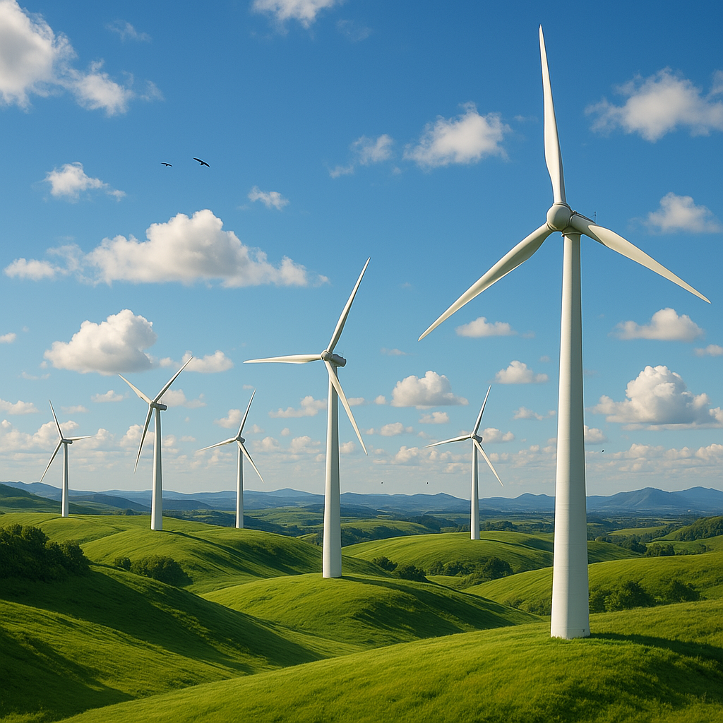

A wind farm, also known as a wind park or wind power plant, is a collection of wind turbines clustered together to generate electricity from wind energy. These farms can be located on land (onshore) or at sea (offshore). Wind farms play a significant role in renewable energy production by converting wind's kinetic energy into electrical energy, which is then fed into the power grid.

* **Function:**

Wind turbines in a farm convert wind's kinetic energy into mechanical energy, which then drives a generator to produce electricity.

* **Scale:**

Wind farms can vary in size, from a few turbines to several hundred, spread over a large area.

* **Onshore vs. Offshore:**

Onshore wind farms are located on land, often in areas with consistent wind patterns, while offshore wind farms are situated in bodies of water, like the sea or large lakes.

* **Grid Connection:**

Electricity generated by a wind farm is usually collected through a network of cables and then stepped up in voltage by transformers before being integrated into the main electricity grid for distribution and consumption.

* **Land Use:**

While wind farms require space for the turbines, the land between them can often be used for other purposes, such as agriculture.

**2. Solar Farm**

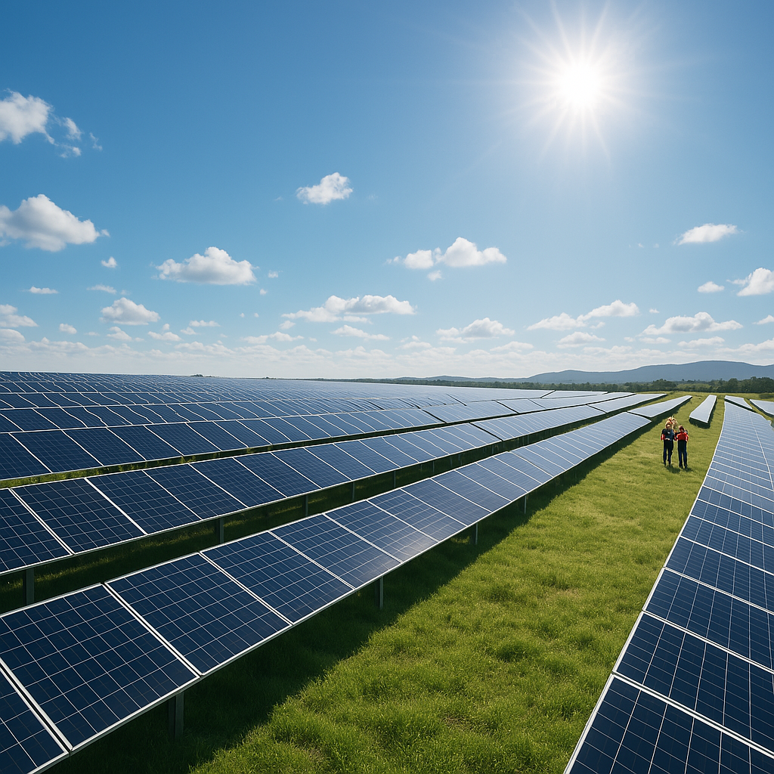

A solar farm, also known as a solar park or photovoltaic power station, is a large-scale installation of solar panels designed to generate electricity from sunlight. These farms convert solar radiation into electrical energy, feeding it into the power grid for public or industrial consumption.

Key features of solar farms:

* **Large-scale installations:** Solar farms are significantly larger than residential or commercial solar systems.
* **Grid connection:** They are designed to feed electricity directly into the power grid.
* **Renewable energy source:** Solar farms harness the sun's energy, a clean and sustainable resource, to generate electricity.

Benefits of solar farms:

* **Reduced reliance on fossil fuels:** Solar farms offer a cleaner alternative to traditional energy sources, reducing carbon emissions and reliance on fossil fuels.
* **Contribution to renewable energy targets:** They help countries and regions meet their renewable energy goals.
* **Cost-effective in the long run:** While the initial investment can be substantial, solar farms can provide long-term cost savings and predictable energy costs.

**3. Power Generation Plant**

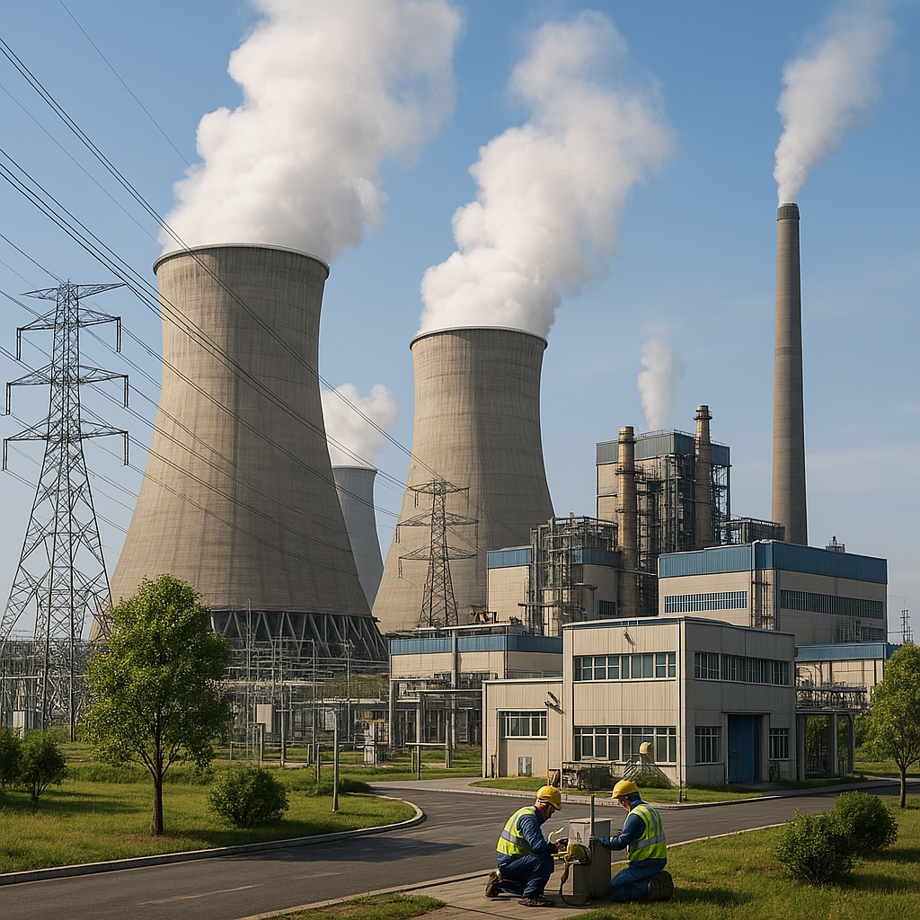

A power generation plant, also known as a power plant or powerhouse, is an industrial facility designed to produce electrical power. It converts various forms of energy (fossil fuels like coal, oil, gas or nuclear) into electrical energy, which is then distributed to consumers. These plants typically contain one or more generators, which are machines that convert mechanical energy into electrical energy.

What it does:

* **Energy Conversion:**

Power plants are designed to transform different forms of energy (like thermal, mechanical, chemical, or nuclear) into electrical energy.

* **Generating Electricity:**

The core function of a power plant is to produce electricity, typically using generators that convert mechanical energy into electrical energy through electromagnetic induction.

* **Transmission to the Grid:**

The electricity generated is then transmitted through power lines to the electrical grid, making it available for homes, businesses, and industries.

Types of power plants:

Power plants are categorized based on the energy source they utilize:

* **Fossil Fuel Power Plants:**

These plants burn fossil fuels like coal, natural gas, or oil to produce heat, which is then used to generate steam that drives turbines connected to generators.

* **Nuclear Power Plants:**

Nuclear power plants use nuclear fission to generate heat, which in turn produces steam to drive turbines and generate electricity.

**4. Hydroelectric plant**

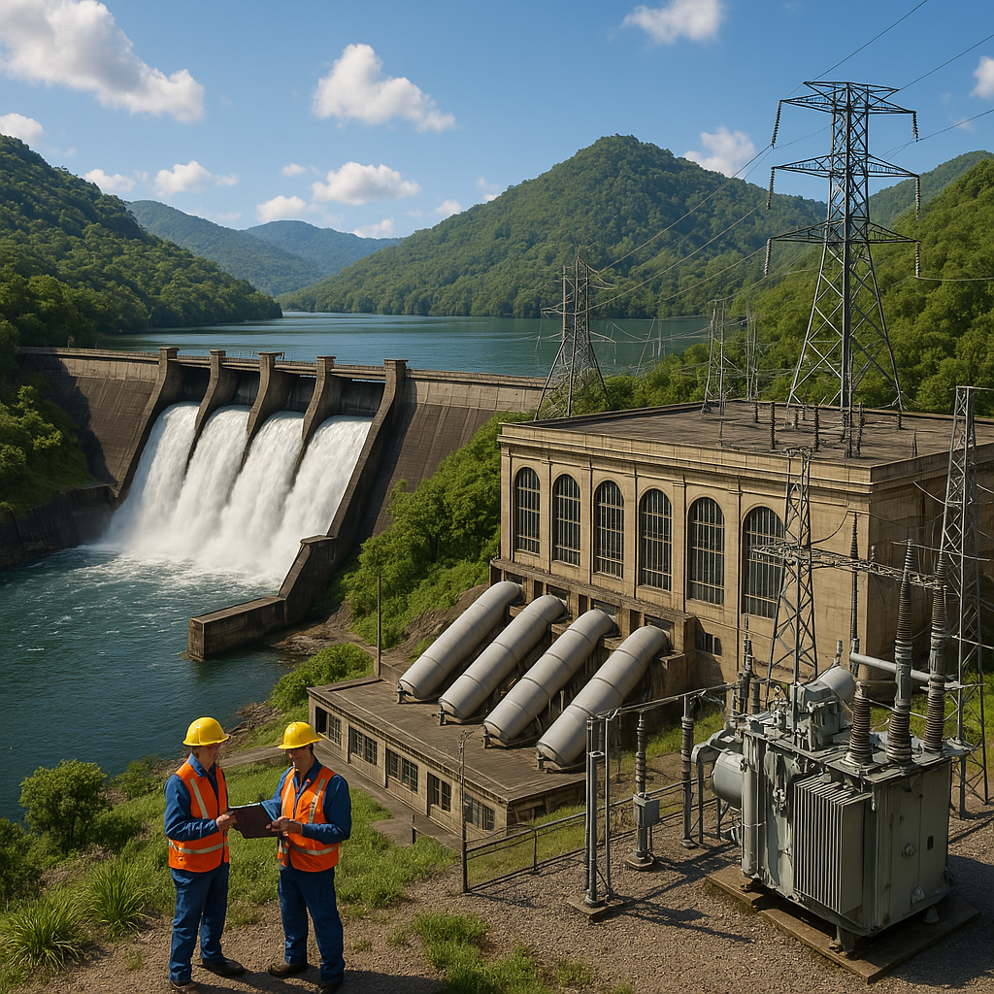

A hydroelectric power plant, also known as a hydropower plant, uses the energy of moving water to generate electricity. It's a renewable energy source that relies on the Earth's water cycle to produce power. The process involves harnessing the kinetic energy of flowing water, typically through a dam and reservoir system, to turn turbines and generate electricity.

Hydroelectric power plants are typically located on or near a water source, such as a river or stream.

Dams are built to create reservoirs, which store large volumes of water.

The height of the dam and the volume of water stored in the reservoir determine the potential energy available.

**5. Turbine**

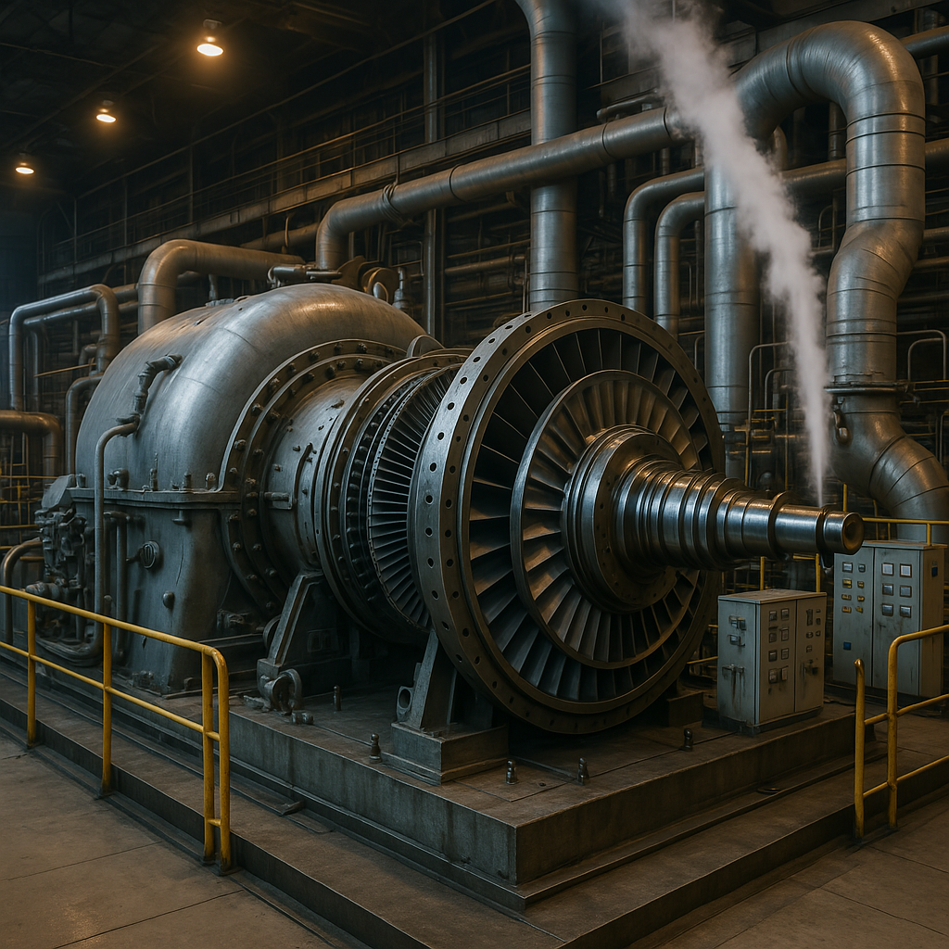

In power generation, turbines and generators are essential components that work together to convert energy into electricity. Turbines are machines that convert the kinetic energy of a fluid (like steam, water, or gas) into mechanical energy in the form of rotational motion. This rotational energy is then transferred to a generator, which converts the mechanical energy into electrical energy.

Turbines are designed to extract energy from a flowing fluid and convert it into rotational motion.

Different types of turbines exist, including steam turbines (used in thermal and nuclear power plants), gas turbines (used in gas power plants), and hydroelectric turbines (used in dams).

A turbine typically consists of a rotor with blades. As the fluid flows over the blades, it causes the rotor to spin, which in turn drives the generator.

**6. Smart Meter**

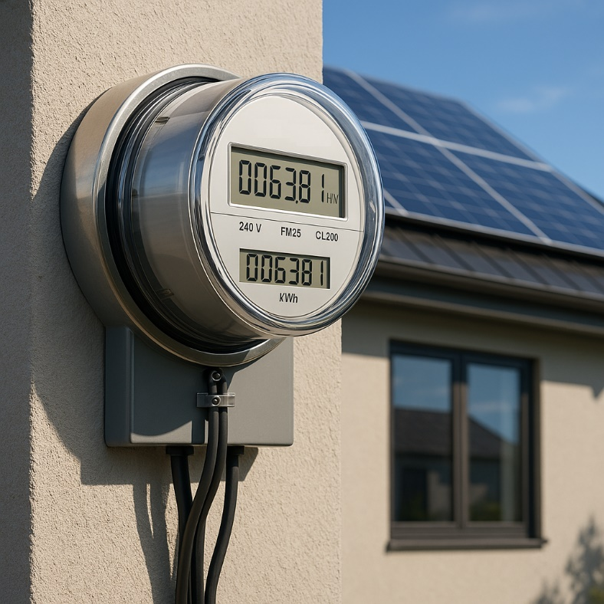

A smart meter is an advanced digital energy meter that records and transmits electricity consumption data to utility providers in real-time. Unlike traditional meters, smart meters eliminate the need for manual meter readings and provide consumers with detailed insights into their energy usage. This allows for better energy management, potentially leading to cost savings and increased energy efficiency.

**Key features of smart meters:**

* **Real-time data:**

Smart meters record energy consumption continuously and transmit this data to the utility company, typically every 15 minutes or so.

* **Remote reading:**

They eliminate the need for physical meter readings, saving time and resources for both consumers and utilities.

* **Enhanced monitoring:**

Consumers can access detailed information about their energy consumption through online portals or mobile apps, allowing them to identify areas where they can reduce usage and save money.

* **Demand response:**

Smart meters enable utilities to implement demand response programs, which can incentivize consumers to reduce energy usage during peak hours, potentially leading to lower energy costs.

* **Prepaid options:**

Some smart meters offer prepaid options, allowing consumers to manage their energy spending more effectively.

* **Integration with smart grids:**

Smart meters play a crucial role in the development of smart grids, which are more efficient and reliable energy distribution networks

**7. Switch**

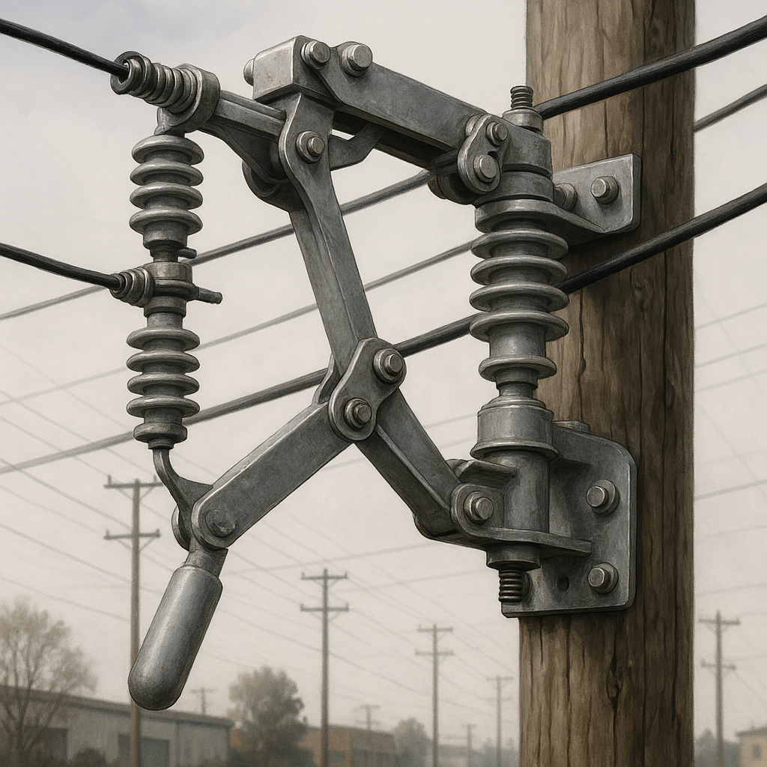

In electrical distribution systems, switches are devices that connect or disconnect the flow of electricity within a circuit. They serve various purposes, including isolating equipment for maintenance, diverting power flow, and protecting circuits from overloads and short circuits.

**Types of Switches in Distribution Systems:**

* **Circuit Breakers:**

These are designed to automatically interrupt the flow of electricity during an overload or short circuit, protecting equipment and preventing fires.

* **Load Break Switches:**

These switches are designed to interrupt the flow of electricity under load conditions, allowing for the safe disconnection and reconnection of power lines.

* **Disconnect Switches:**

These switches provide a visible break in the circuit, allowing for the safe isolation of equipment for maintenance or repairs.

* **Switch-Disconnectors:**

These devices combine the functions of a switch and a disconnector, providing both switching and isolation capabilities.

* **Fuse Switches:**

These switches incorporate fuses for overload and short circuit protection, offering a combination of switching and protective functions.

* **Automatic Transfer Switches (ATS):**

These switches automatically transfer the power supply from a primary source to a backup source (like a generator) in case of a power outage.

**8. Substation**

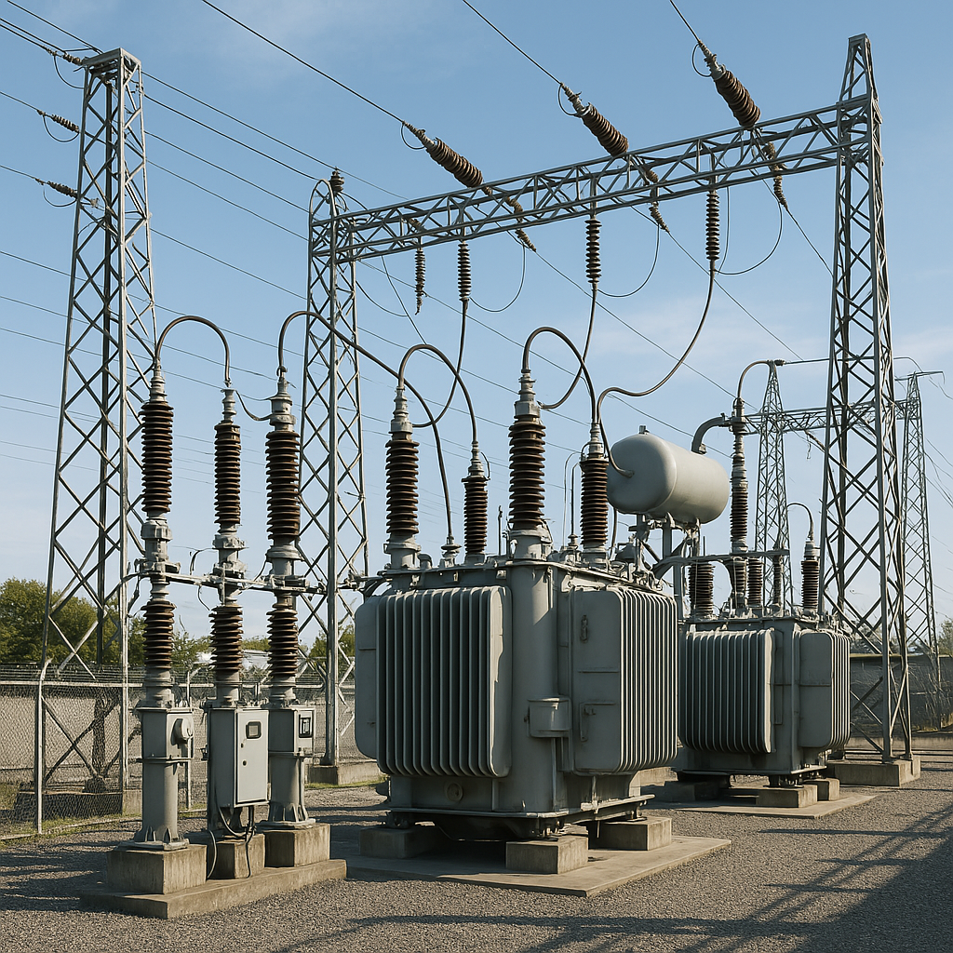

An electrical substation is a key part of the power grid, acting as a go-between for power generation and distribution. It's a facility where electricity is switched, transformed (voltage is adjusted), and controlled to ensure reliable power delivery. Substations are vital for maintaining a stable and efficient electricity supply to homes and businesses.

**What it does:**

* **Voltage Transformation:**

Substations use transformers to step up or step down the voltage of electricity. This is crucial because electricity is transmitted at high voltages over long distances to minimize energy loss, then stepped down to safer levels for local distribution.

* **Switching and Control:**

Substations incorporate switchgear and circuit breakers to control the flow of electricity, allowing for the connection and disconnection of equipment or circuits, as well as fault protection.

* **Distribution:**

Substations deliver electricity to different parts of the grid and ultimately to consumers.

**Types of Substations:**

* **Transmission Substations:** Part of the high-voltage transmission network.
* **Distribution Substations:** Connect to the lower-voltage distribution network.
* **Transformer Substations:** Specifically designed for voltage transformation.

**9. Substation Busbar**

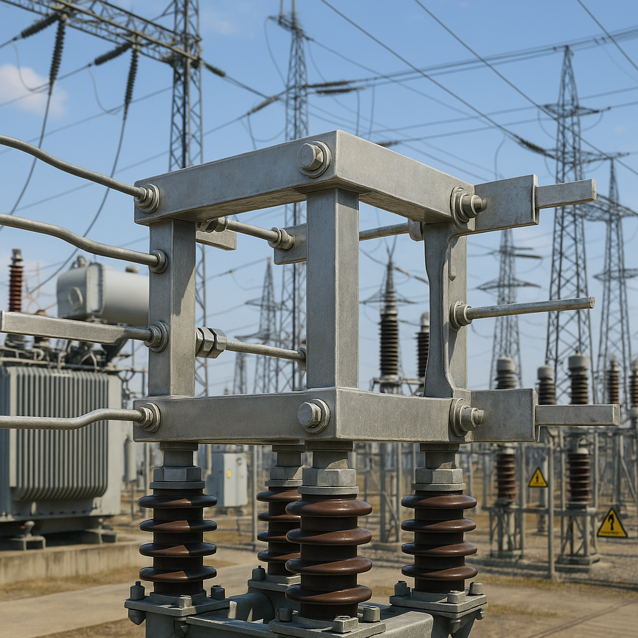

A substation busbar is a metallic conductor that serves as a central connection point for multiple electrical circuits in a substation. It acts as a common junction where incoming and outgoing power lines connect, facilitating the distribution of electrical power. Busbars are crucial for efficient and reliable power distribution in substations, allowing for the connection of various equipment like transformers, circuit breakers, and other switchgear.

**Key Functions and Features:**

* **Connection Point:**

Busbars provide a central point for connecting multiple incoming and outgoing electrical circuits, simplifying power distribution.

* **Current Carrying Capacity:**

They are designed to carry large currents, making them suitable for both low and high voltage applications.

* **Flexibility:**

Busbars offer flexibility in substation design, allowing for different configurations and expansions based on specific needs.

* **Types:**

Busbars can be solid, hollow, or flexible, and are typically made of copper or aluminum.

**10. Gas Meters**

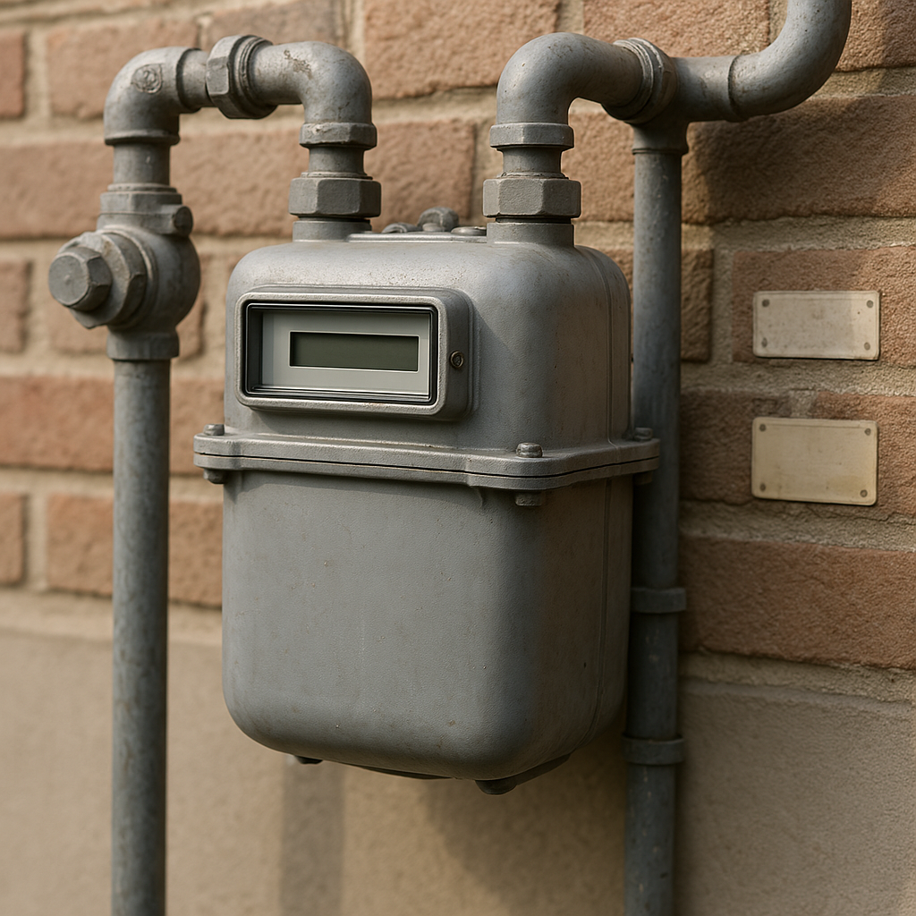

A gas meter is a specialized [flow meter](https://en.wikipedia.org/wiki/Flow_meter), used to [measure](https://en.wikipedia.org/wiki/Measurement) the volume of [fuel gases](https://en.wikipedia.org/wiki/Fuel_gas) such as [natural gas](https://en.wikipedia.org/wiki/Natural_gas) and [liquefied petroleum gas](https://en.wikipedia.org/wiki/Liquefied_petroleum_gas). Gas meters are used at residential, commercial, and industrial buildings that consume fuel gas supplied by a gas [utility](https://en.wikipedia.org/wiki/Public_utility). Gases are more difficult to measure than liquids, because measured volumes are highly affected by temperature and pressure. Gas meters measure a defined volume, regardless of the pressurized quantity or quality of the gas flowing through the meter. Temperature, pressure, and heating value compensation must be made to measure actual amount and value of gas moving through a meter.

Several different designs of gas meters are in common use, depending on the volumetric flow rate of gas to be measured, the range of flows anticipated, the type of gas being measured, and other factors.

**11. Pressure Gauge**

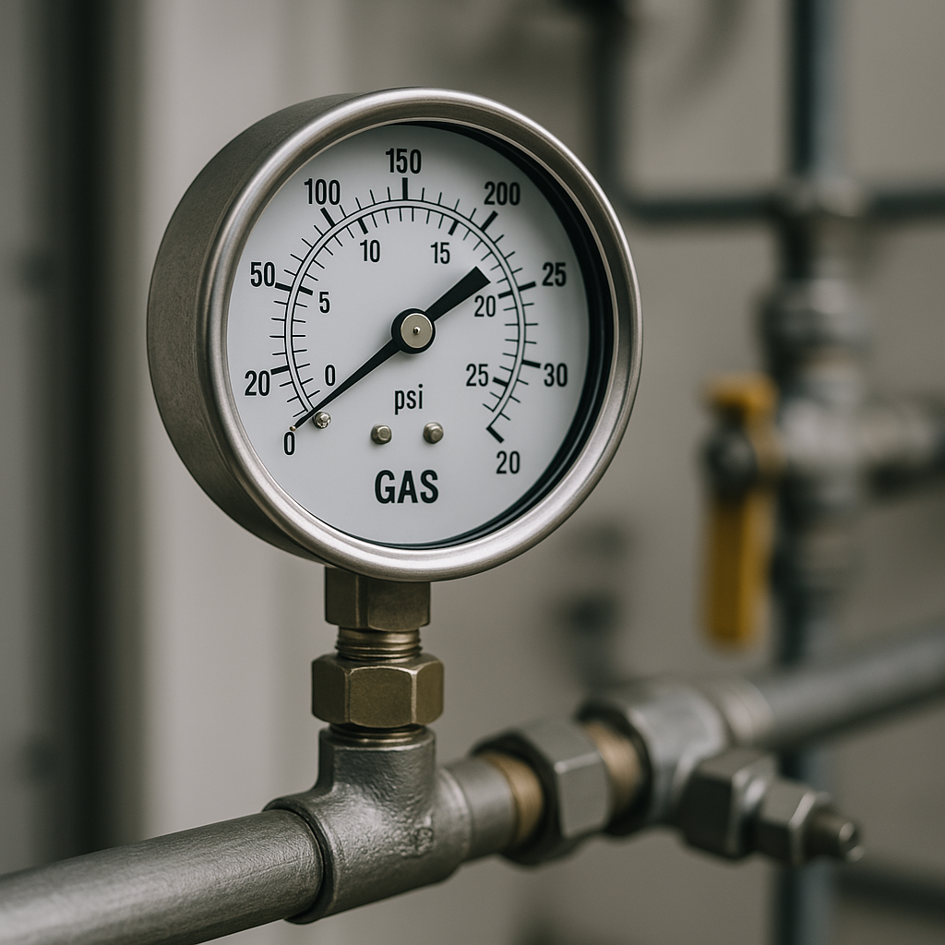

Gas pressure gauges are essential instruments in the gas utility industry, used to measure and monitor gas pressure within pipelines and systems. They are crucial for ensuring safe and efficient gas delivery by maintaining pressure within specified limits, detecting leaks, and aiding in system control.

Key functions and applications:

* **Monitoring Gas Pressure:**

Pressure gauges provide real-time readings of gas pressure, allowing operators to monitor the system and ensure it operates within safe and efficient parameters.

* **Safety:**

Gauges help prevent over-pressurization, which can lead to equipment damage, leaks, or even explosions.

* **Leak Detection:**

Sudden drops in pressure, as indicated by the gauge, can signal potential leaks in the system, allowing for timely intervention.

* **System Control:**

By monitoring pressure, operators can adjust gas flow and pressure levels as needed to maintain optimal system performance.

**12. Flame Arrestor**

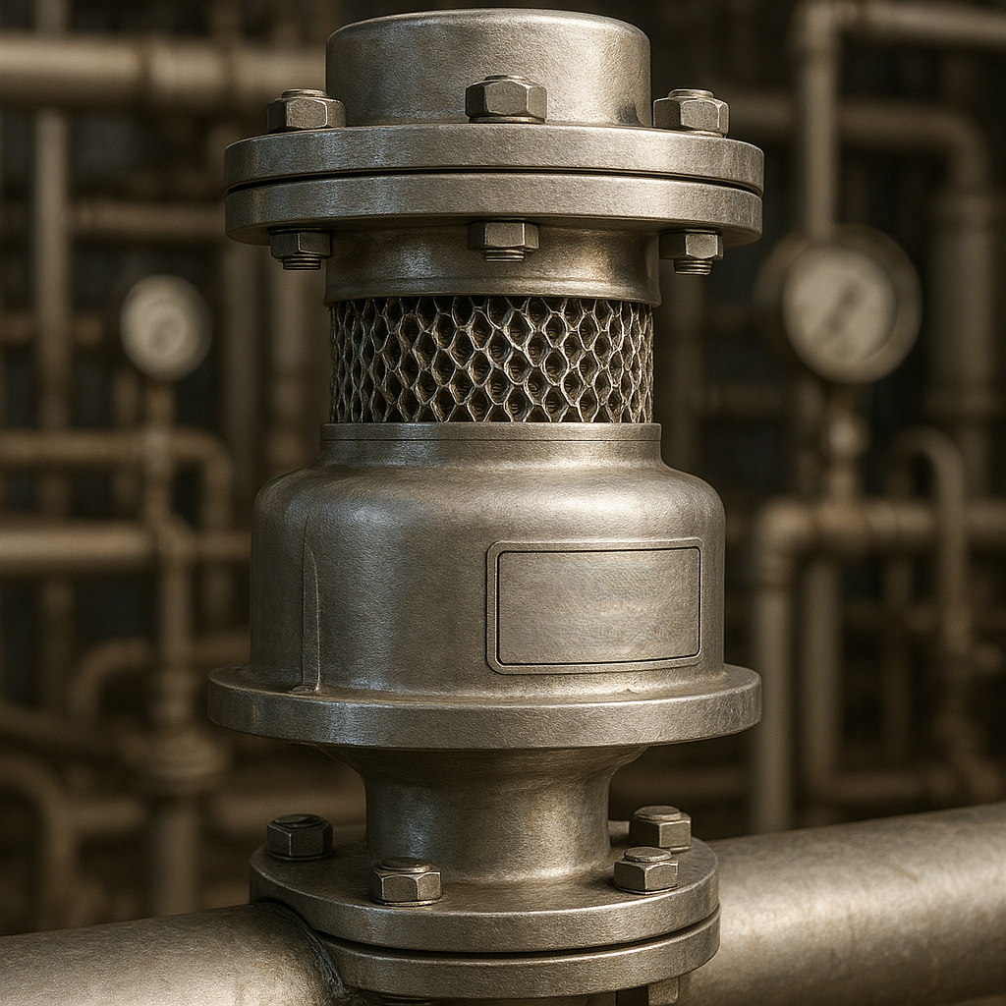

A flame arrester is a safety device designed to prevent the spread of fire or explosions by stopping the propagation of flames in flammable gas or vapor mixtures. It allows the flow of gases or vapors under normal conditions but extinguishes flames by cooling the hot gases below their ignition temperature. Flame arresters are crucial in various industrial applications to protect equipment and personnel from potential hazards.

**How it works:**

* Flame arresters typically consist of a matrix of small passages or channels.
* When a flame front passes through these passages, the heat is dissipated into the arrester material, and the flame is effectively quenched.
* This prevents the flame from traveling further and igniting other parts of the system.

**Types of flame arrestors:**

* Deflagration arresters: Designed to stop flames traveling at subsonic speeds.
* Detonation arresters: Designed to withstand flames traveling at supersonic speeds and the resulting pressure waves.
* End-of-line arresters: Typically installed at the end of a pipe or vent.
* Inline arresters: Installed within a pipeline to protect sections of the system.